**Ideation Phase**

**Brainstorm & Idea Prioritization Template**

|  |  |
| --- | --- |
| Date | 20 June 2025 |
| Team ID | LTVIP2025TMID60795 |
| Project Name | Pattern Sense: Classifying Fabric Patterns Using Deep Learning |
| Maximum Marks | 4 Marks |

**Brainstorm & Idea Prioritization Template:**

Brainstorming provides a free and open environment that encourages both team members to participate in the creative thinking process that leads to solving the core challenge: accurately classifying fabric patterns using deep learning. Out-of-the-box ideas are welcome and built upon. Both members are encouraged to collaborate, helping each other develop a wide range of innovative solutions.

**Use this template in your own brainstorming sessions so your team can unleash their imagination and start shaping concepts around *Pattern Sense: Classifying Fabric Patterns Using Deep Learning*, even if you're not sitting in the same room.**

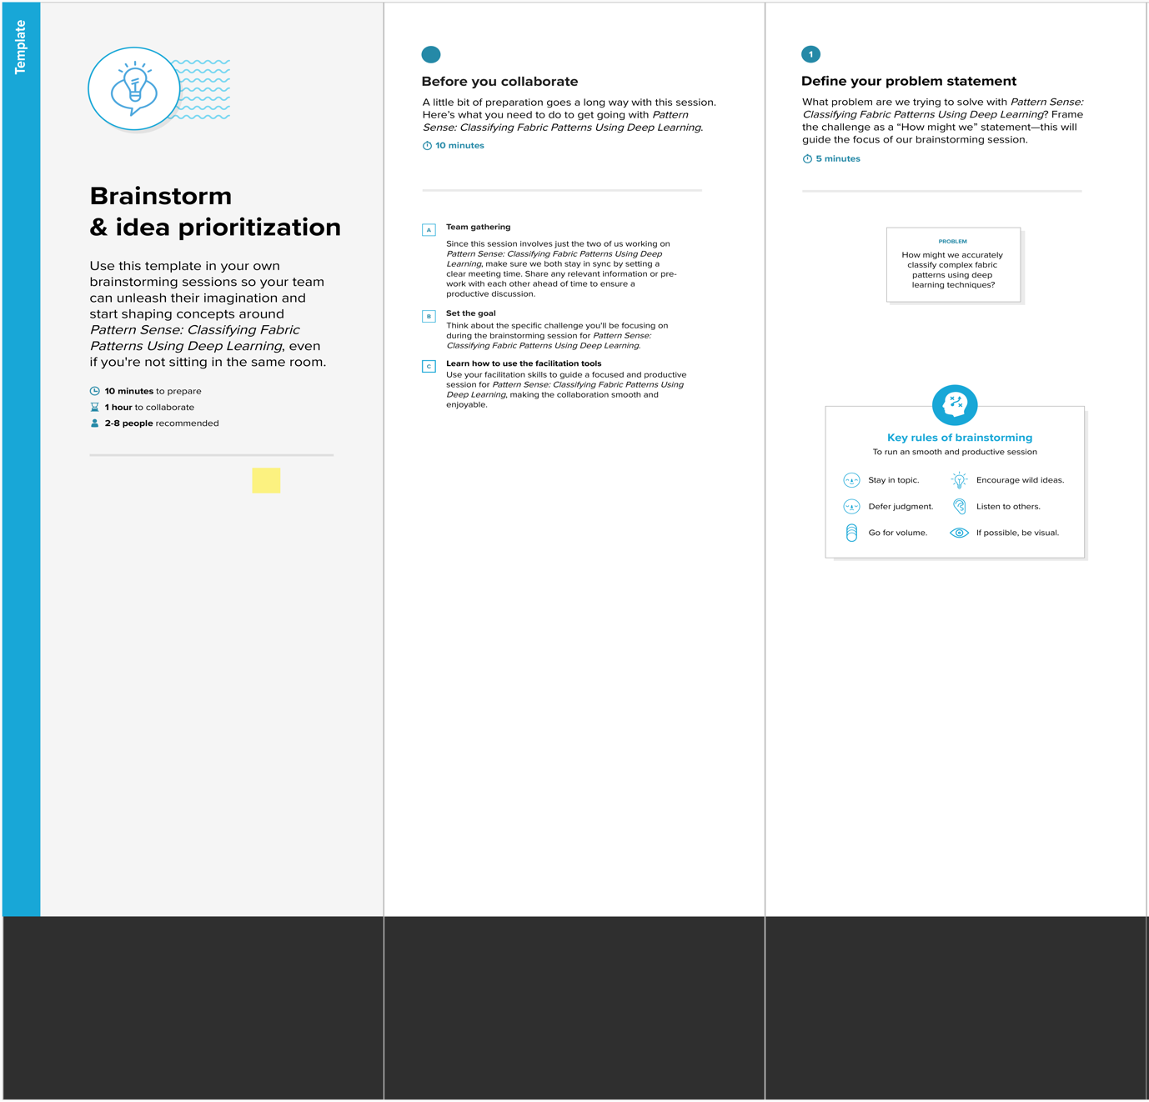**Step-1: Team Gathering, Collaboration and Select the Problem Statement**

**Step-2: Brainstorm, Idea Listing and Grouping**

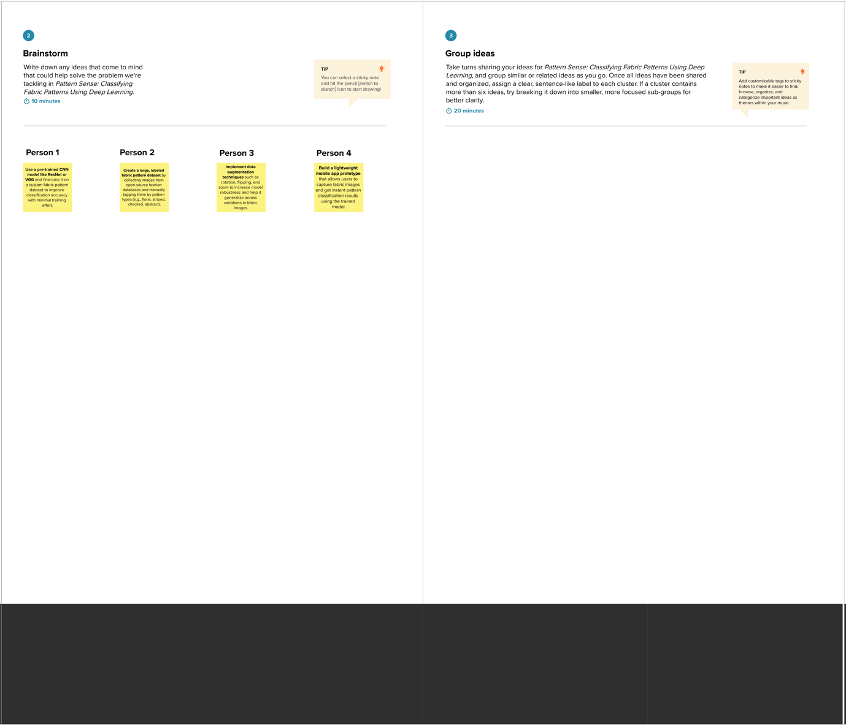

**Step-3: Idea Prioritization**

